

**COMSATS UNIVERSITY ISLAMABAD**

**ATTOCK CAMPUS**

**SUBMITTED TO: Sir Muhammad Kamran**

**SUBMITTED BY: Ali Nawaz Khan**

**REGISTRATION NO: SP20-BSE-014**

**SUBJECT: MAD-Theory**

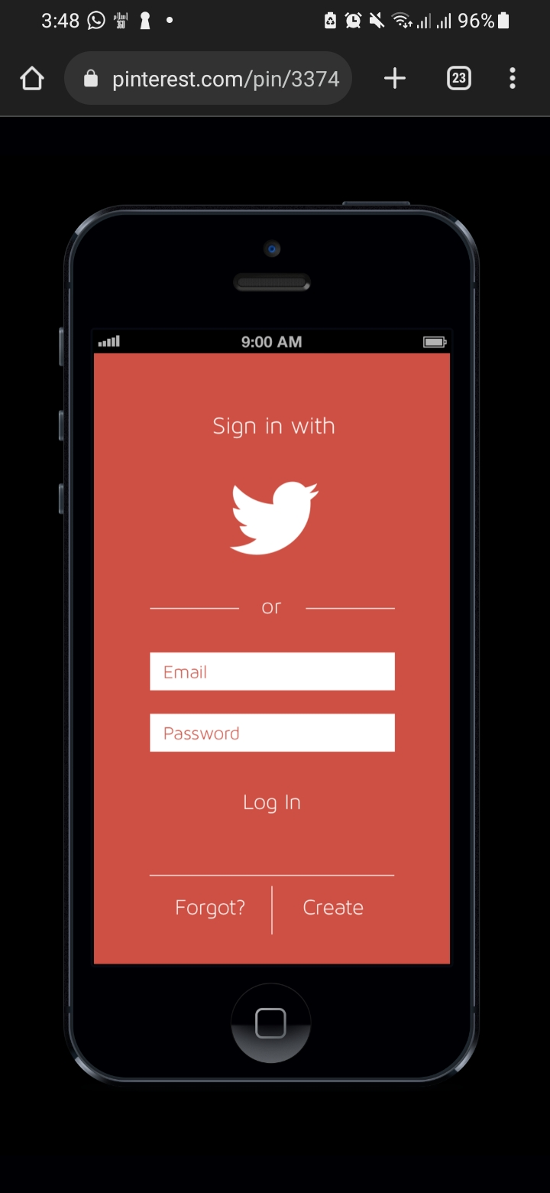

**CODE:**

import React from 'react';

import { StyleSheet, Text, SafeAreaView ,Image, View } from 'react-native';

export default function App(){

return(

  <SafeAreaView style={[styles.container, containerstyle]}>

  <View>

  <Text style={styles.box1}>Sign in with</Text>

  </View>

  <View style={styles.box2}>

    <Image style={styles.Imagesi}

    source = {require("./assets/twitter.png")}>

    </Image>

  </View>

  <View>

  <Text style={styles.box3}>_________________   or   ________________</Text>

  </View>

  <View>

  <Text style={styles.box4}>Email</Text>

  </View>

  <View>

  <Text style={styles.box4}>Password</Text>

  </View>

  <View>

  <Text style={styles.box5}>Log In</Text>

  </View>

  <View>

  <Text style={styles.box3}>_____________________________________</Text>

  </View>

  <View>

  <Text style={styles.box5}><span style={{color: 'white'}}>Forgot?</span>    |   <span style={{color: 'white'}}>Create</span></Text>

  </View>

  </SafeAreaView>

);

}

const containerstyle={backgroundColor:'red'}

const styles=StyleSheet.create(

  {

    container:{

      flex:1,

    justifyContent:'center',

    alignItems:'center',

  },

  box1:{

    color:'white',

    justifyContent:'center',

    alignItems:'center',

    textAlign:'center',

    fontSize: 40,

    marginBottom:10

  },

  box2:{

    marginBottom:10,

    width:50,

    height:50

  },

  box3:{

    color: 'white',

    justifyContent:'center',

    alignItems:'center',

    marginTop:30,

    fontSize: 13,

  },

  box4:{

    marginTop:40,

    width: 200 ,

    height:35,

    color:'red',

    backgroundColor:"white",

    textAlign:'start',

    fontSize: 18,

  },

  Imagesi:{

    marginBottom:70,

    width:80,

    height:75

  },

  box5:{

    color:'white',

    justifyContent:'center',

    alignItems:'center',

    marginTop:10,

    fontSize: 20,

  },

}

    )

**OUTPUT:**

